*UPDATED* Monkeypox Testing Procedure

Monkey Pox samples must be sent to the NV State Public Health Lab (NSPHL) at UNR. Do not send labs based on patient insurance. NO EXCEPTIONS WILL BE MADE.

PURPOSE
Effective communication and precautionary measures between specimen collection teams and laboratory staff are essential to maximizing quality of sample collection and proper turnaround time of testing.

EQUIPMENT AND MATERIALS NEEDED
Culture collection and transport container *(Non-cotton swab in Viral Transport Media – VTM)*

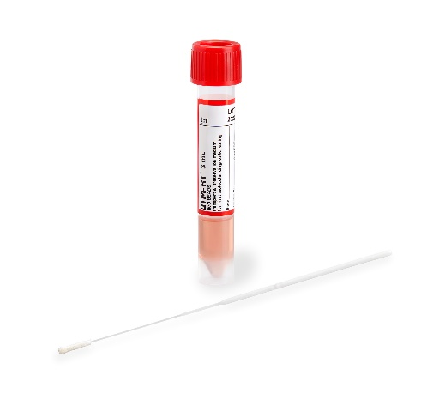
PROCEDURE FOR COLLECTING THE SWAB
- If Monkeypox is suspected and patient meets appropriate risk factors, ensure patient is in proper precautions. notify these departments with patient information ASAP:
  - Microbiology (982- 5538)
  - Washoe County Health District (775-328-2447)
  - Email Infection prevention at Infection.prevention.control@Renown.org
- Patients with rule out Monkeypox cannot have viral cultures ordered and will be cancelled by lab. PCR testing is the only acceptable test at this time:
- Before collecting sample, perform hand hygiene and wear appropriate personal protective equipment (PPE).
  - Patient should be placed in Enhanced Droplet & Contact precautions (N95, gloves and gown).
  - If patient is being ruled out for disseminated herpes zoster or varicella place patient in Airborne (N95 respirator) and contact precautions.
- Open the swab package by grasping the plastic at the opposite end from the soft tip. Without contaminating the tip remove the swab from its packaging.
- Collect at least 2 swabs per lesion and swab vigorously to collect adequate DNA.
  - De-roofing lesion is not necessary
  - Lesions should preferably be collected from different locations on the body with differing appearance and collected in pairs (suggest 2-3 lesions in total). Each swab is placed into a separate VTM container.
  - Lesion crusts in VTM is also an acceptable specimen type.
- Remove the cap from the viral transport media (VTM) tube, then place the soft end of the collection swab into the tube. Be careful to keep the cap from touching any materials that may contaminate your sample. Label each distinct collection site on specimen container.
- Apply patient identification label and fill out lab requisition (See attached). It will be ordered as a MISCELLANEOUS test in EPIC.
- Place in specimen bag and transport refrigerated (2-8⁰ C) to Renown laboratory with State lab requisition (DO NOT PLACE SPECIMENS IN THE TUBE SYSTEM).
- Sample can be sent via Routine lab courier (982-4152).
- Perform standard cleaning and disinfection procedures.
- TAT for testing is ~24-72 hours. Testing is batched at the NSPHL M-F 8am-5pm.

